**Program 6-8**

**Program 6** Create two files of XML and JSON type with values for City_Name, Latitude, Longitude, Temperature, and Humidity. Develop an application to create an activity with two buttons to parse the XML and JSON files which when clicked should display the data in their respective layouts side by side.

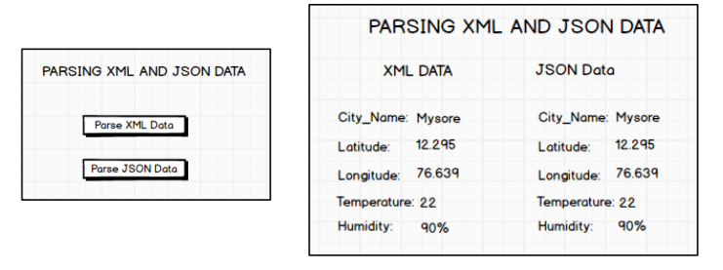

1. Create a New Android Project with Empty Activity.

2. Open activity_main.xml file from res→ layout folder, check/add ConstraintLayout as the root view.

3. Create the layout design using Drag and Drop framework.

4. Add Listeners to Button Click Event:

• Create a class which implements OnClickListener interface.

• Override onClick() method of OnClickListener Interface.

• Register the button for click event by calling setOnClickListener() method of View class and pass the object of the class that implemented OnClickListener Interface.

5. Create assets folder

Creating Assets Folder in Android

Right Click on app folder → New → Folder → Assets Folder → Press Finish Button

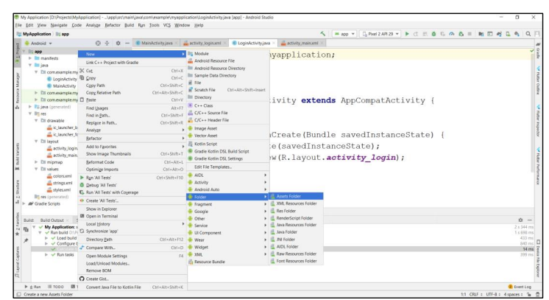

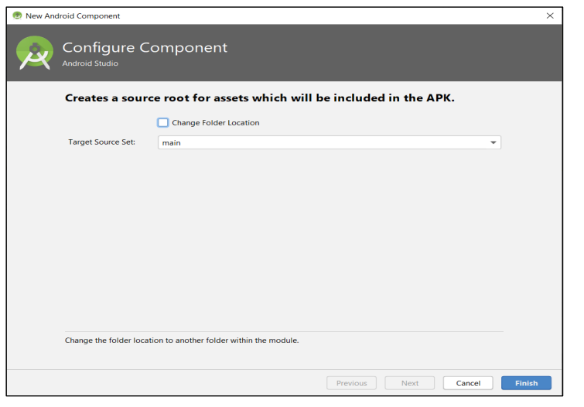

6. Create input.xml file inside assets folder and paste the below Xml Data

<?xml version="1.0"?>

<records>

<employee>

<city_name>Mysore</city_name>

<Latitude>12.295</Latitude>

<Longitude>76.639</Longitude>

<Temperature>22</Temperature>

<Humidity>90%</Humidity>

</employee>

</records>

7. Create input.json file inside assets folder and paste the below Json

{

"employee": {

"city_name": "Mysore",

"Latitude": "12.295",

"Longitude": "76.639",

"Temperature": 22,

"Humidity": "90%"

}

}

8. Read the XML and Json Data in the files and display on screen

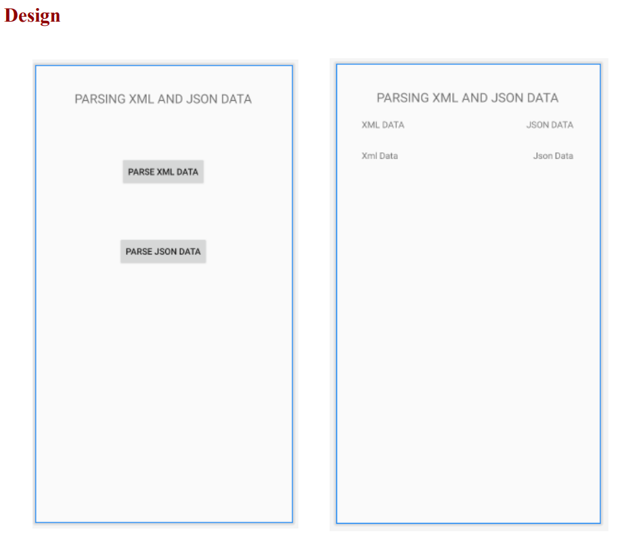

**activity_main.xml**

<?xml version="1.0" encoding="utf-8"?>

<androidx.constraintlayout.widget.ConstraintLayout

xmlns:android="http://schemas.android.com/apk/res/android"

xmlns:app="http://schemas.android.com/apk/res-auto"

xmlns:tools="http://schemas.android.com/tools"

android:layout_width="match_parent"

android:layout_height="match_parent"

tools:context=".MainActivity">

<Button

android:id="@+id/btn_parsexml"

android:layout_width="wrap_content"

android:layout_height="wrap_content"

android:layout_marginTop="80dp"

android:text="Parse XML Data"

app:layout_constraintEnd_toEndOf="parent"

app:layout_constraintStart_toStartOf="parent"

app:layout_constraintTop_toBottomOf="@+id/textView4" />

<Button

android:id="@+id/btn_parsejson"

android:layout_width="wrap_content"

android:layout_height="wrap_content"

android:layout_marginTop="80dp"

android:text="Parse Json Data"

app:layout_constraintEnd_toEndOf="parent"

app:layout_constraintStart_toStartOf="parent"

app:layout_constraintTop_toBottomOf="@+id/btn_parsexml" />

<TextView

android:id="@+id/textView4"

android:layout_width="wrap_content"

android:layout_height="wrap_content"

android:layout_marginTop="40dp"

android:text="PARSING XML AND JSON DATA"

android:textSize="20dp"

app:layout_constraintEnd_toEndOf="parent"

app:layout_constraintStart_toStartOf="parent"

app:layout_constraintTop_toTopOf="parent" />

</androidx.constraintlayout.widget.ConstraintLayout>

**activity_view.xml**

<?xml version="1.0" encoding="utf-8"?>

<androidx.constraintlayout.widget.ConstraintLayoutxmlns:android="http://schemas.andr

oid.com/apk/res/android"

xmlns:app="http://schemas.android.com/apk/res-auto"

xmlns:tools="http://schemas.android.com/tools"

android:layout_width="match_parent"

android:layout_height="match_parent"

tools:context=".ViewActivity">

<TextView

android:id="@+id/lbl_xml_data"

android:layout_width="wrap_content"

android:layout_height="wrap_content"

android:layout_marginTop="30dp"

android:text="Xml Data"

app:layout_constraintStart_toStartOf="@+id/textView2"

app:layout_constraintTop_toBottomOf="@+id/textView2" />

<TextView

android:id="@+id/textView"

android:layout_width="wrap_content"

android:layout_height="wrap_content"

android:layout_marginTop="40dp"

android:text="PARSING XML AND JSON DATA"

android:textSize="20dp"

app:layout_constraintEnd_toEndOf="parent"

app:layout_constraintStart_toStartOf="parent"

app:layout_constraintTop_toTopOf="parent" />

<TextView

android:id="@+id/textView2"

android:layout_width="wrap_content"

android:layout_height="wrap_content"

android:layout_marginStart="40dp"

android:layout_marginTop="20dp"

android:text="XML DATA"

app:layout_constraintStart_toStartOf="parent"

app:layout_constraintTop_toBottomOf="@+id/textView" />

<TextView

android:id="@+id/textView3"

android:layout_width="wrap_content"

android:layout_height="wrap_content"

android:layout_marginTop="20dp"

android:layout_marginEnd="40dp"

android:text="JSON DATA"

app:layout_constraintEnd_toEndOf="parent"

app:layout_constraintTop_toBottomOf="@+id/textView" />

<TextView

android:id="@+id/lbl_json_data"

android:layout_width="wrap_content"

android:layout_height="wrap_content"

android:layout_marginTop="30dp"

android:text="Json Data"

app:layout_constraintEnd_toEndOf="@+id/textView3"

app:layout_constraintTop_toBottomOf="@+id/textView3" />

</androidx.constraintlayout.widget.ConstraintLayout>

**MainActivity.java**

package com.example.parta_program6;

import androidx.appcompat.app.AppCompatActivity;

import android.content.Intent;

import android.os.Bundle;

import android.view.View;

import android.widget.Button;

public class MainActivityextendsAppCompatActivityimplementsView.OnClickListener {

Button btnParseXml,btnParseJson;

@Override

protected void onCreate(Bundle savedInstanceState) {

super.onCreate(savedInstanceState);

setContentView(R.layout.activity_main);

btnParseXml=(Button)findViewById(R.id.btn_parsexml);

btnParseJson=(Button)findViewById(R.id.btn_parsejson);

btnParseJson.setOnClickListener(this);

btnParseXml.setOnClickListener(this);

} @Override

public void onClick(View v) {

if(v.equals(btnParseJson))

{

Intent it=new Intent(this,ViewActivity.class);

it.putExtra("mode",1);

startActivity(it);

}

else if(v.equals(btnParseXml))

{

Intent it=new Intent(this,ViewActivity.class);

it.putExtra("mode",2);

startActivity(it);

}

}

}

**ViewActivity.java**

package com.example.parta_program6;

import androidx.appcompat.app.AppCompatActivity;

import android.os.Bundle;

import android.widget.TextView;

import org.json.JSONObject;

import org.w3c.dom.Document;

import org.w3c.dom.Element;

import org.w3c.dom.Node;

import org.w3c.dom.NodeList;

import java.io.InputStream;

import javax.xml.parsers.DocumentBuilder;

import javax.xml.parsers.DocumentBuilderFactory;

public class ViewActivityextendsAppCompatActivity {

TextViewlblXmlData,lblJsonData;

int mode=0;

@Override

protected void onCreate(Bundle savedInstanceState) {

super.onCreate(savedInstanceState);

setContentView(R.layout.activity_view);

lblXmlData=(TextView)findViewById(R.id.lbl_xml_data);

lblJsonData=(TextView)findViewById(R.id.lbl_json_data);

mode=getIntent().getIntExtra("mode",0); if(mode==1)

parseJson();

else

parseXmlDocument();

}

public String parseXmlDocument()

{

try {

InputStream is = getAssets().open("input.xml");

DocumentBuilderFactorydbFactory = DocumentBuilderFactory.newInstance();

DocumentBuilderdBuilder = dbFactory.newDocumentBuilder();

Document doc = dBuilder.parse(is);

Element element=doc.getDocumentElement();

element.normalize();

NodeListnList = doc.getElementsByTagName("employee");

for (int i=0; i<nList.getLength(); i++) {

Node node = nList.item(i);

if (node.getNodeType() == Node.ELEMENT_NODE) {

Element element2 = (Element) node;

lblXmlData.setText("City Name : " + getValue("city_name", element2)+"\n");

lblXmlData.append("Latitude : " + getValue("Latitude", element2)+"\n");

lblXmlData.append("Longitude : " + getValue("Longitude", element2)+"\n");

lblXmlData.append("Temperature : " + getValue("Temperature", element2)+"\n");

lblXmlData.append("Humidity : " + getValue("Humidity", element2)+"\n");

}

}

}

catch (Exception e) {e.printStackTrace();}

return null;

}

private static String getValue(String tag, Element element) {

NodeListnodeList = element.getElementsByTagName(tag).item(0).getChildNodes();

Node node = nodeList.item(0);

return node.getNodeValue();

}

public void parseJson()

{

try {

InputStreaminputStream=getAssets().open("input.json");

byte[] data=new byte[inputStream.available()];

inputStream.read(data); String readData=new String(data);

JSONObjectjsonObject=new JSONObject(readData);

JSONObject jsonObject1=jsonObject.getJSONObject("employee");

lblJsonData.setText("City Name:"+jsonObject1.getString("city_name")+"\n");

lblJsonData.append("Latitude:"+jsonObject1.getString("Latitude")+"\n");

lblJsonData.append("Longitude"+jsonObject1.getString("Longitude")+"\n");

lblJsonData.append("Temperature:"+jsonObject1.getInt("Temperature")+"\n");

lblJsonData.append("Humidity"+jsonObject1.getString("Humidity")+"\n");

}

catch (Exception e) {e.printStackTrace();}

}

}

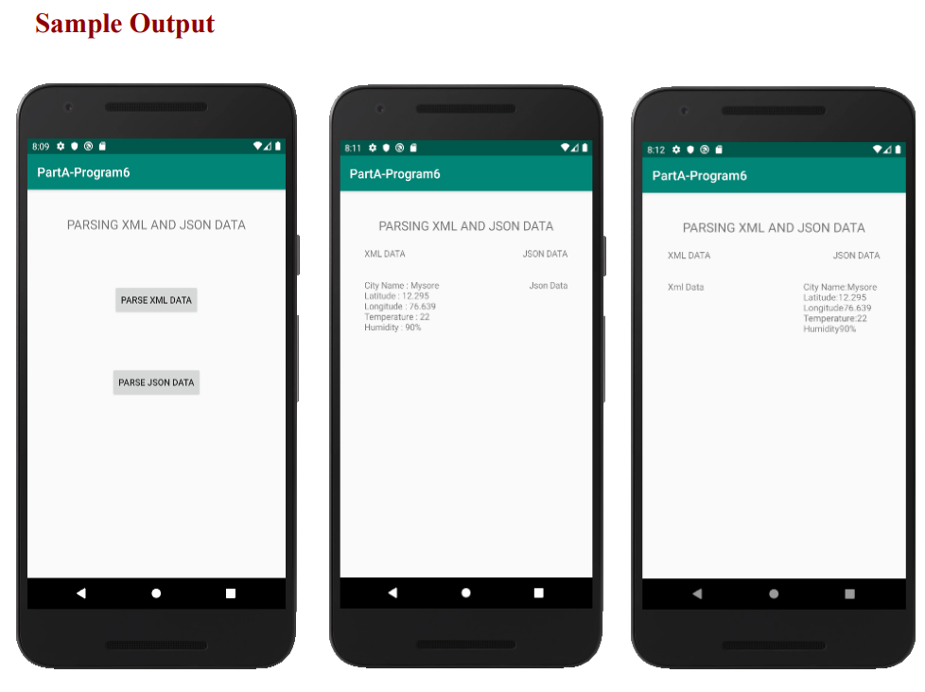

Program 7

Develop a simple application with one EditText so that the user can write some text in it. Create a button called “Convert Text to Speech” that converts the user input text into voice

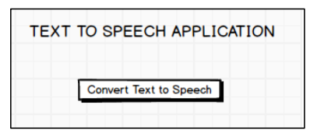

1. Create a New Android Project with Empty Activity.

2. Open activity_main.xml file from res→ layout folder, check/add ConstraintLayout as the

root view.

3. Create the layout design using Drag and Drop framework.

4. Add Listeners to Button Click Event:

• Create a class which implments OnClickListener interface.

• Override onClick() method of OnClickListener Interface.

• Register the button for click event by calling setOnClickListener() method of View

class and pass the object of the class that implemented OnClickListener Interface.

5. Initialize TextToSpeech Engine and the Language to Speak using setLanguage() method

6. Use Speak() method to speak the text passed to it.

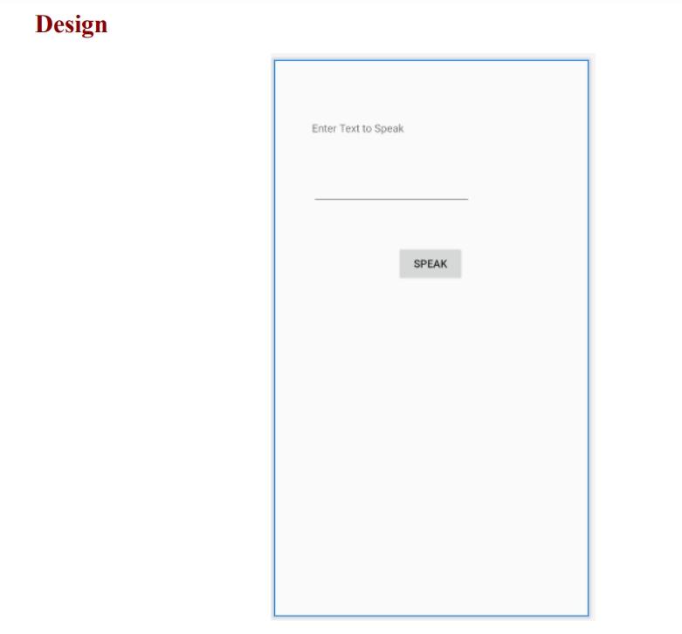

**activity_main.xml**

<?xml version="1.0" encoding="utf-8"?>

<androidx.constraintlayout.widget.ConstraintLayoutxmlns:android="http://schemas.andr

oid.com/apk/res/android"

xmlns:app="http://schemas.android.com/apk/res-auto"

xmlns:tools="http://schemas.android.com/tools"

android:id="@+id/txt_texttospeak"

android:layout_width="match_parent"

android:layout_height="match_parent"

tools:context=".MainActivity">

<TextView

android:id="@+id/textView"

android:layout_width="wrap_content"

android:layout_height="wrap_content"

android:layout_marginStart="50dp"

android:layout_marginTop="80dp"

android:text="Enter Text to Speak"

app:layout_constraintStart_toStartOf="parent"

app:layout_constraintTop_toTopOf="parent" />

<EditText

android:id="@+id/editText"

android:layout_width="wrap_content"

android:layout_height="wrap_content"

android:layout_marginTop="48dp"

android:ems="10"

android:inputType="textPersonName"

app:layout_constraintEnd_toEndOf="parent"

app:layout_constraintHorizontal_bias="0.0"

app:layout_constraintStart_toStartOf="@+id/textView"

app:layout_constraintTop_toBottomOf="@+id/textView" />

<Button

android:id="@+id/btn_speak"

android:layout_width="wrap_content"

android:layout_height="wrap_content"

android:layout_marginTop="52dp"

android:text="Speak"

app:layout_constraintEnd_toEndOf="parent"

app:layout_constraintStart_toStartOf="parent"

app:layout_constraintTop_toBottomOf="@+id/editText" />

</androidx.constraintlayout.widget.ConstraintLayout>

**MainActivity.java**

package com.example.parta.parta_program7;

import androidx.appcompat.app.AppCompatActivity;

import android.os.Bundle;

import android.speech.tts.TextToSpeech;

import android.view.View;

import android.widget.Button;

import android.widget.EditText;

import android.widget.Toast;

import java.util.Locale;

public class MainActivityextendsAppCompatActivityimplementsView.OnClickListener {

EditTexttxtSpeak;

Button btnSpeak;

TextToSpeech textToSpeech;

@Override

protected void onCreate(Bundle savedInstanceState) {

super.onCreate(savedInstanceState);

setContentView(R.layout.activity_main);

txtSpeak=(EditText)findViewById(R.id.editText);

btnSpeak=(Button)findViewById(R.id.btn_speak);

btnSpeak.setOnClickListener(this);

textToSpeech=new TextToSpeech(getBaseContext(),

new TextToSpeech.OnInitListener() {

@Override

public void onInit(int status) {

if(status!=TextToSpeech.ERROR)

{

Toast.makeText(getBaseContext(),"Success", Toast.LENGTH_LONG).show();

}

}

});

textToSpeech.setLanguage(Locale.UK);

}

public void onClick(View v)

{

String text=txtSpeak.getText().toString();

textToSpeech.speak(text,TextToSpeech.QUEUE_FLUSH,null);

}

}

Program 8

Create an activity like a phone dialer with CALL and SAVE buttons. On pressing the CALL button, it must call the phone number and on pressing the SAVE button it must save the number to the phone contacts.

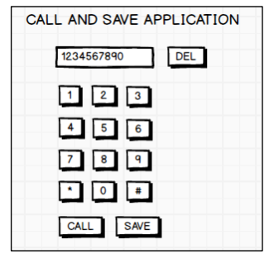

1. Create a New Android Project with Empty Activity.

2. Open activity_main.xml file from res→ layout folder, check/add ConstraintLayout as the

root view.

3. Create the layout design using Drag and Drop framework.

4. Add Listeners to Button Click Event:

• Create a class which implments OnClickListener interface.

• Override onClick() method of OnClickListener Interface.

• Register the button for click event by calling setOnClickListener() method of View

class and pass the object of the class that implemented OnClickListener Interface.

5. Declare uses permission android.permission.CALL_PHONE in the manifest file.

6. Use ACTION_CALL intent name and pass the “tel:<phone-number> as URI in intent

data and start the call activity.

7. Use intent name and pass the “Telephone Number” and “unknown” as name as intent

data call Contacts Save Activity.

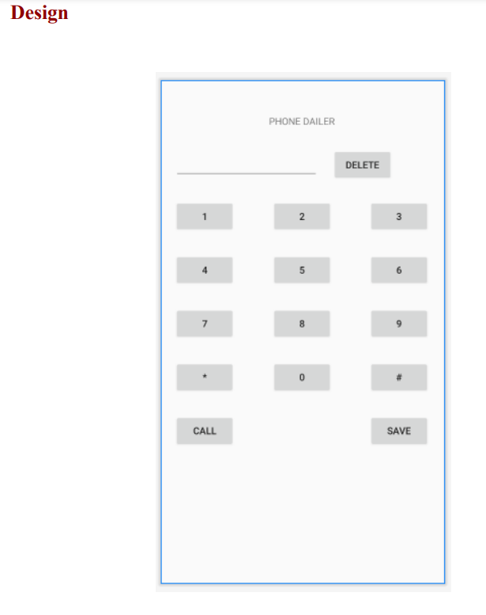

activity_main.xml

<?xml version="1.0" encoding="utf-8"?>

<androidx.constraintlayout.widget.ConstraintLayoutxmlns:android="http://schemas.andr

oid.com/apk/res/android"

xmlns:app="http://schemas.android.com/apk/res-auto"

xmlns:tools="http://schemas.android.com/tools"

android:layout_width="match_parent"

android:layout_height="match_parent"

tools:context=".MainActivity">

<TextView

android:id="@+id/textView"

android:layout_width="wrap_content"

android:layout_height="wrap_content"

android:layout_marginTop="50dp"

android:text="PHONE DAILER"

app:layout_constraintEnd_toEndOf="parent"

app:layout_constraintStart_toStartOf="parent"

app:layout_constraintTop_toTopOf="parent" />

<EditText

android:id="@+id/txt_phonenumber"

android:layout_width="wrap_content"

android:layout_height="wrap_content"

android:layout_marginStart="20dp"

android:layout_marginTop="30dp"

android:ems="10"

android:inputType="textPersonName"

app:layout_constraintStart_toStartOf="parent"

app:layout_constraintTop_toBottomOf="@+id/textView" />

<Button

android:id="@+id/btn_delete"

android:layout_width="wrap_content"

android:layout_height="wrap_content"

android:layout_marginStart="20dp"

android:layout_marginTop="30dp"

android:text="Delete"

app:layout_constraintStart_toEndOf="@+id/txt_phonenumber"

app:layout_constraintTop_toBottomOf="@+id/textView" />

<Button

android:id="@+id/btn_one"

android:layout_width="wrap_content"

android:layout_height="wrap_content"

android:layout_marginStart="20dp"

android:layout_marginTop="30dp"

android:text="1"

app:layout_constraintStart_toStartOf="parent"

app:layout_constraintTop_toBottomOf="@+id/txt_phonenumber" />

<Button

android:id="@+id/btn_two"

android:layout_width="wrap_content"

android:layout_height="wrap_content"

android:layout_marginTop="30dp"

android:text="2"

app:layout_constraintEnd_toStartOf="@+id/btn_three"

app:layout_constraintStart_toEndOf="@+id/btn_one"

app:layout_constraintTop_toBottomOf="@+id/txt_phonenumber" />

<Button

android:id="@+id/btn_three"

android:layout_width="wrap_content"

android:layout_height="wrap_content"

android:layout_marginTop="30dp"

android:layout_marginEnd="20dp"

android:text="3"

app:layout_constraintEnd_toEndOf="parent"

app:layout_constraintTop_toBottomOf="@+id/txt_phonenumber" />

<Button

android:id="@+id/btn_four"

android:layout_width="wrap_content"

android:layout_height="wrap_content"

android:layout_marginStart="20dp"

android:layout_marginTop="30dp"

android:text="4"

app:layout_constraintStart_toStartOf="parent"

app:layout_constraintTop_toBottomOf="@+id/btn_one" />

<Button

android:id="@+id/btn_five"

android:layout_width="wrap_content"

android:layout_height="wrap_content"

android:layout_marginTop="30dp"

android:text="5"

app:layout_constraintEnd_toStartOf="@+id/btn_six"

app:layout_constraintStart_toEndOf="@+id/btn_four"

app:layout_constraintTop_toBottomOf="@+id/btn_two" />

<Button

android:id="@+id/btn_six"

android:layout_width="wrap_content"

android:layout_height="wrap_content"

android:layout_marginTop="30dp"

android:layout_marginEnd="20dp"

android:text="6"

app:layout_constraintEnd_toEndOf="parent"

app:layout_constraintTop_toBottomOf="@+id/btn_three" />

<Button

android:id="@+id/btn_seven"

android:layout_width="wrap_content"

android:layout_height="wrap_content"

android:layout_marginStart="20dp"

android:layout_marginTop="30dp"

android:text="7"

app:layout_constraintStart_toStartOf="parent"

app:layout_constraintTop_toBottomOf="@+id/btn_four" />

<Button

android:id="@+id/btn_eight"

android:layout_width="wrap_content"

android:layout_height="wrap_content"

android:layout_marginTop="30dp" android:text="8"

app:layout_constraintEnd_toStartOf="@+id/btn_nine"

app:layout_constraintStart_toEndOf="@+id/btn_seven"

app:layout_constraintTop_toBottomOf="@+id/btn_five" />

<Button

android:id="@+id/btn_nine"

android:layout_width="wrap_content"

android:layout_height="wrap_content"

android:layout_marginTop="30dp"

android:layout_marginEnd="20dp"

android:text="9"

app:layout_constraintEnd_toEndOf="parent"

app:layout_constraintTop_toBottomOf="@+id/btn_six" />

<Button

android:id="@+id/btn_zero"

android:layout_width="wrap_content"

android:layout_height="wrap_content"

android:layout_marginTop="30dp"

android:text="0"

app:layout_constraintEnd_toEndOf="parent"

app:layout_constraintStart_toStartOf="parent"

app:layout_constraintTop_toBottomOf="@+id/btn_eight" />

<Button

android:id="@+id/btn_call"

android:layout_width="wrap_content"

android:layout_height="wrap_content"

android:layout_marginStart="20dp"

android:layout_marginTop="30dp"

android:text="Call"

app:layout_constraintStart_toStartOf="parent"

app:layout_constraintTop_toBottomOf="@+id/btn_zero" />

<Button

android:id="@+id/btn_save"

android:layout_width="wrap_content"

android:layout_height="wrap_content"

android:layout_marginTop="30dp"

android:layout_marginEnd="20dp"

android:text="Save"

app:layout_constraintEnd_toEndOf="parent"

app:layout_constraintTop_toBottomOf="@+id/btn_zero" />

<Button

android:id="@+id/btn_start"

android:layout_width="wrap_content"

android:layout_height="wrap_content"

android:layout_marginStart="20dp"

android:layout_marginTop="30dp"

android:text="*"

app:layout_constraintStart_toStartOf="parent"

app:layout_constraintTop_toBottomOf="@+id/btn_seven" />

<Button

android:id="@+id/btn_hash"

android:layout_width="wrap_content"

android:layout_height="wrap_content" android:layout_marginTop="30dp"

android:layout_marginEnd="20dp"

android:text="#"

app:layout_constraintEnd_toEndOf="parent"

app:layout_constraintTop_toBottomOf="@+id/btn_nine" />

</androidx.constraintlayout.widget.ConstraintLayout>

MainActivity.java

package com.example.part_a_program_8;

import androidx.appcompat.app.AppCompatActivity;

import android.content.Intent;

import android.net.Uri;

import android.os.Bundle;

import android.provider.ContactsContract;

import android.view.View;

import android.widget.Button;

import android.widget.EditText;

public class MainActivityextends AppCompatActivityimplements View.OnClickListener{

Button btnOne,btnTwo,btnThree,btnFour,btnFive;

Button btnSix,btnSeven,btnEight,btnNine,btnZero;

Button btnDel,btnStar,btnHash,btnCall,btnSave;

EditTexttxtPhonenumber;

@Override

protected void onCreate(Bundle savedInstanceState) {

super.onCreate(savedInstanceState);

setContentView(R.layout.activity_main);

btnOne=(Button)findViewById(R.id.btn_one);

btnOne.setOnClickListener(this);

btnTwo=(Button)findViewById(R.id.btn_two);

btnTwo.setOnClickListener(this);

btnThree=(Button)findViewById(R.id.btn_three);

btnThree.setOnClickListener(this);

btnFour=(Button)findViewById(R.id.btn_four);

btnFour.setOnClickListener(this);

btnFive=(Button)findViewById(R.id.btn_five);

btnFive.setOnClickListener(this);

btnSix=(Button)findViewById(R.id.btn_six);

btnSix.setOnClickListener(this);

btnSeven=(Button)findViewById(R.id.btn_seven);

btnSeven.setOnClickListener(this);

btnEight=(Button)findViewById(R.id.btn_eight);

btnEight.setOnClickListener(this); btnNine=(Button)findViewById(R.id.btn_nine);

btnNine.setOnClickListener(this);

btnZero=(Button)findViewById(R.id.btn_zero);

btnZero.setOnClickListener(this);

btnStar=(Button)findViewById(R.id.btn_start);

btnStar.setOnClickListener(this);

btnHash=(Button)findViewById(R.id.btn_hash);

btnHash.setOnClickListener(this);

btnCall=(Button)findViewById(R.id.btn_call);

btnCall.setOnClickListener(this);

btnSave=(Button)findViewById(R.id.btn_save);

btnSave.setOnClickListener(this);

btnDel=(Button)findViewById(R.id.btn_delete);

btnDel.setOnClickListener(this);

txtPhonenumber=(EditText)findViewById(R.id.txt_phonenumber);

txtPhonenumber.setText("");

}

public void onClick(View v)

{

if(v.equals(btnOne))

txtPhonenumber.append("1");

else if(v.equals(btnTwo))

txtPhonenumber.append("2");

else if(v.equals(btnThree))

txtPhonenumber.append("3");

else if(v.equals(btnFour))

txtPhonenumber.append("4");

else if(v.equals(btnFive))

txtPhonenumber.append("5");

else if(v.equals(btnSix))

txtPhonenumber.append("6");

else if(v.equals(btnSeven))

txtPhonenumber.append("7");

else if(v.equals(btnEight))

txtPhonenumber.append("8");

else if(v.equals(btnNine))

txtPhonenumber.append("9");

else if(v.equals(btnZero))

txtPhonenumber.append("0");

else if(v.equals(btnStar))

txtPhonenumber.append("*");

else if(v.equals(btnHash))

txtPhonenumber.append("#");

else if(v.equals(btnSave))

{

Intent contactIntent= new Intent

(ContactsContract.Intents.Insert.ACTION);

contactIntent.setType

(ContactsContract.RawContacts.CONTENT_TYPE);

contactIntent

.putExtra(ContactsContract.Intents.Insert.NAME,"Unknown");

contactIntent.putExtra(ContactsContract.Intents.Insert.PHONE,

txtPhonenumber.getText().toString());

startActivity(contactIntent);

}

else if(v.equals(btnDel))

{

String data=txtPhonenumber.getText().toString();

if(data.length()>0)

{

txtPhonenumber.setText

(data.substring(0,data.length()-1));

}

else

{

txtPhonenumber.setText("");

}

}

btnCall.setOnClickListener(new View.OnClickListener()

{

@Override

public void onClick(View v) {

String data = txtPhonenumber.getText().toString();

Intent intent=new Intent(Intent.ACTION_DIAL);

intent.setData(Uri.parse("tel:"+ data));

startActivity(intent);

}

}

);

}

} AndriodManifest.xml

<?xml version="1.0" encoding="utf-8"?>

<manifest xmlns:android="http://schemas.android.com/apk/res/android"

package="com.example.part_a_program_8">

<uses-permission android:name="android.permission.CALL_PHONE"/>

<application

android:allowBackup="true"

android:icon="@mipmap/ic_launcher"

android:label="@string/app_name"

android:roundIcon="@mipmap/ic_launcher_round"

android:supportsRtl="true"

android:theme="@style/AppTheme">

<activity android:name=".MainActivity">

<intent-filter>

<action android:name="android.intent.action.MAIN" />

<category android:name="android.intent.category.LAUNCHER" />

</intent-filter>

</activity>

</application>

</manifest>